Numerical simulation of the flow situation
in an experimental device for emulsification

Part of the CONEX-Project
Emulsions with Nanoparticles for New Materials

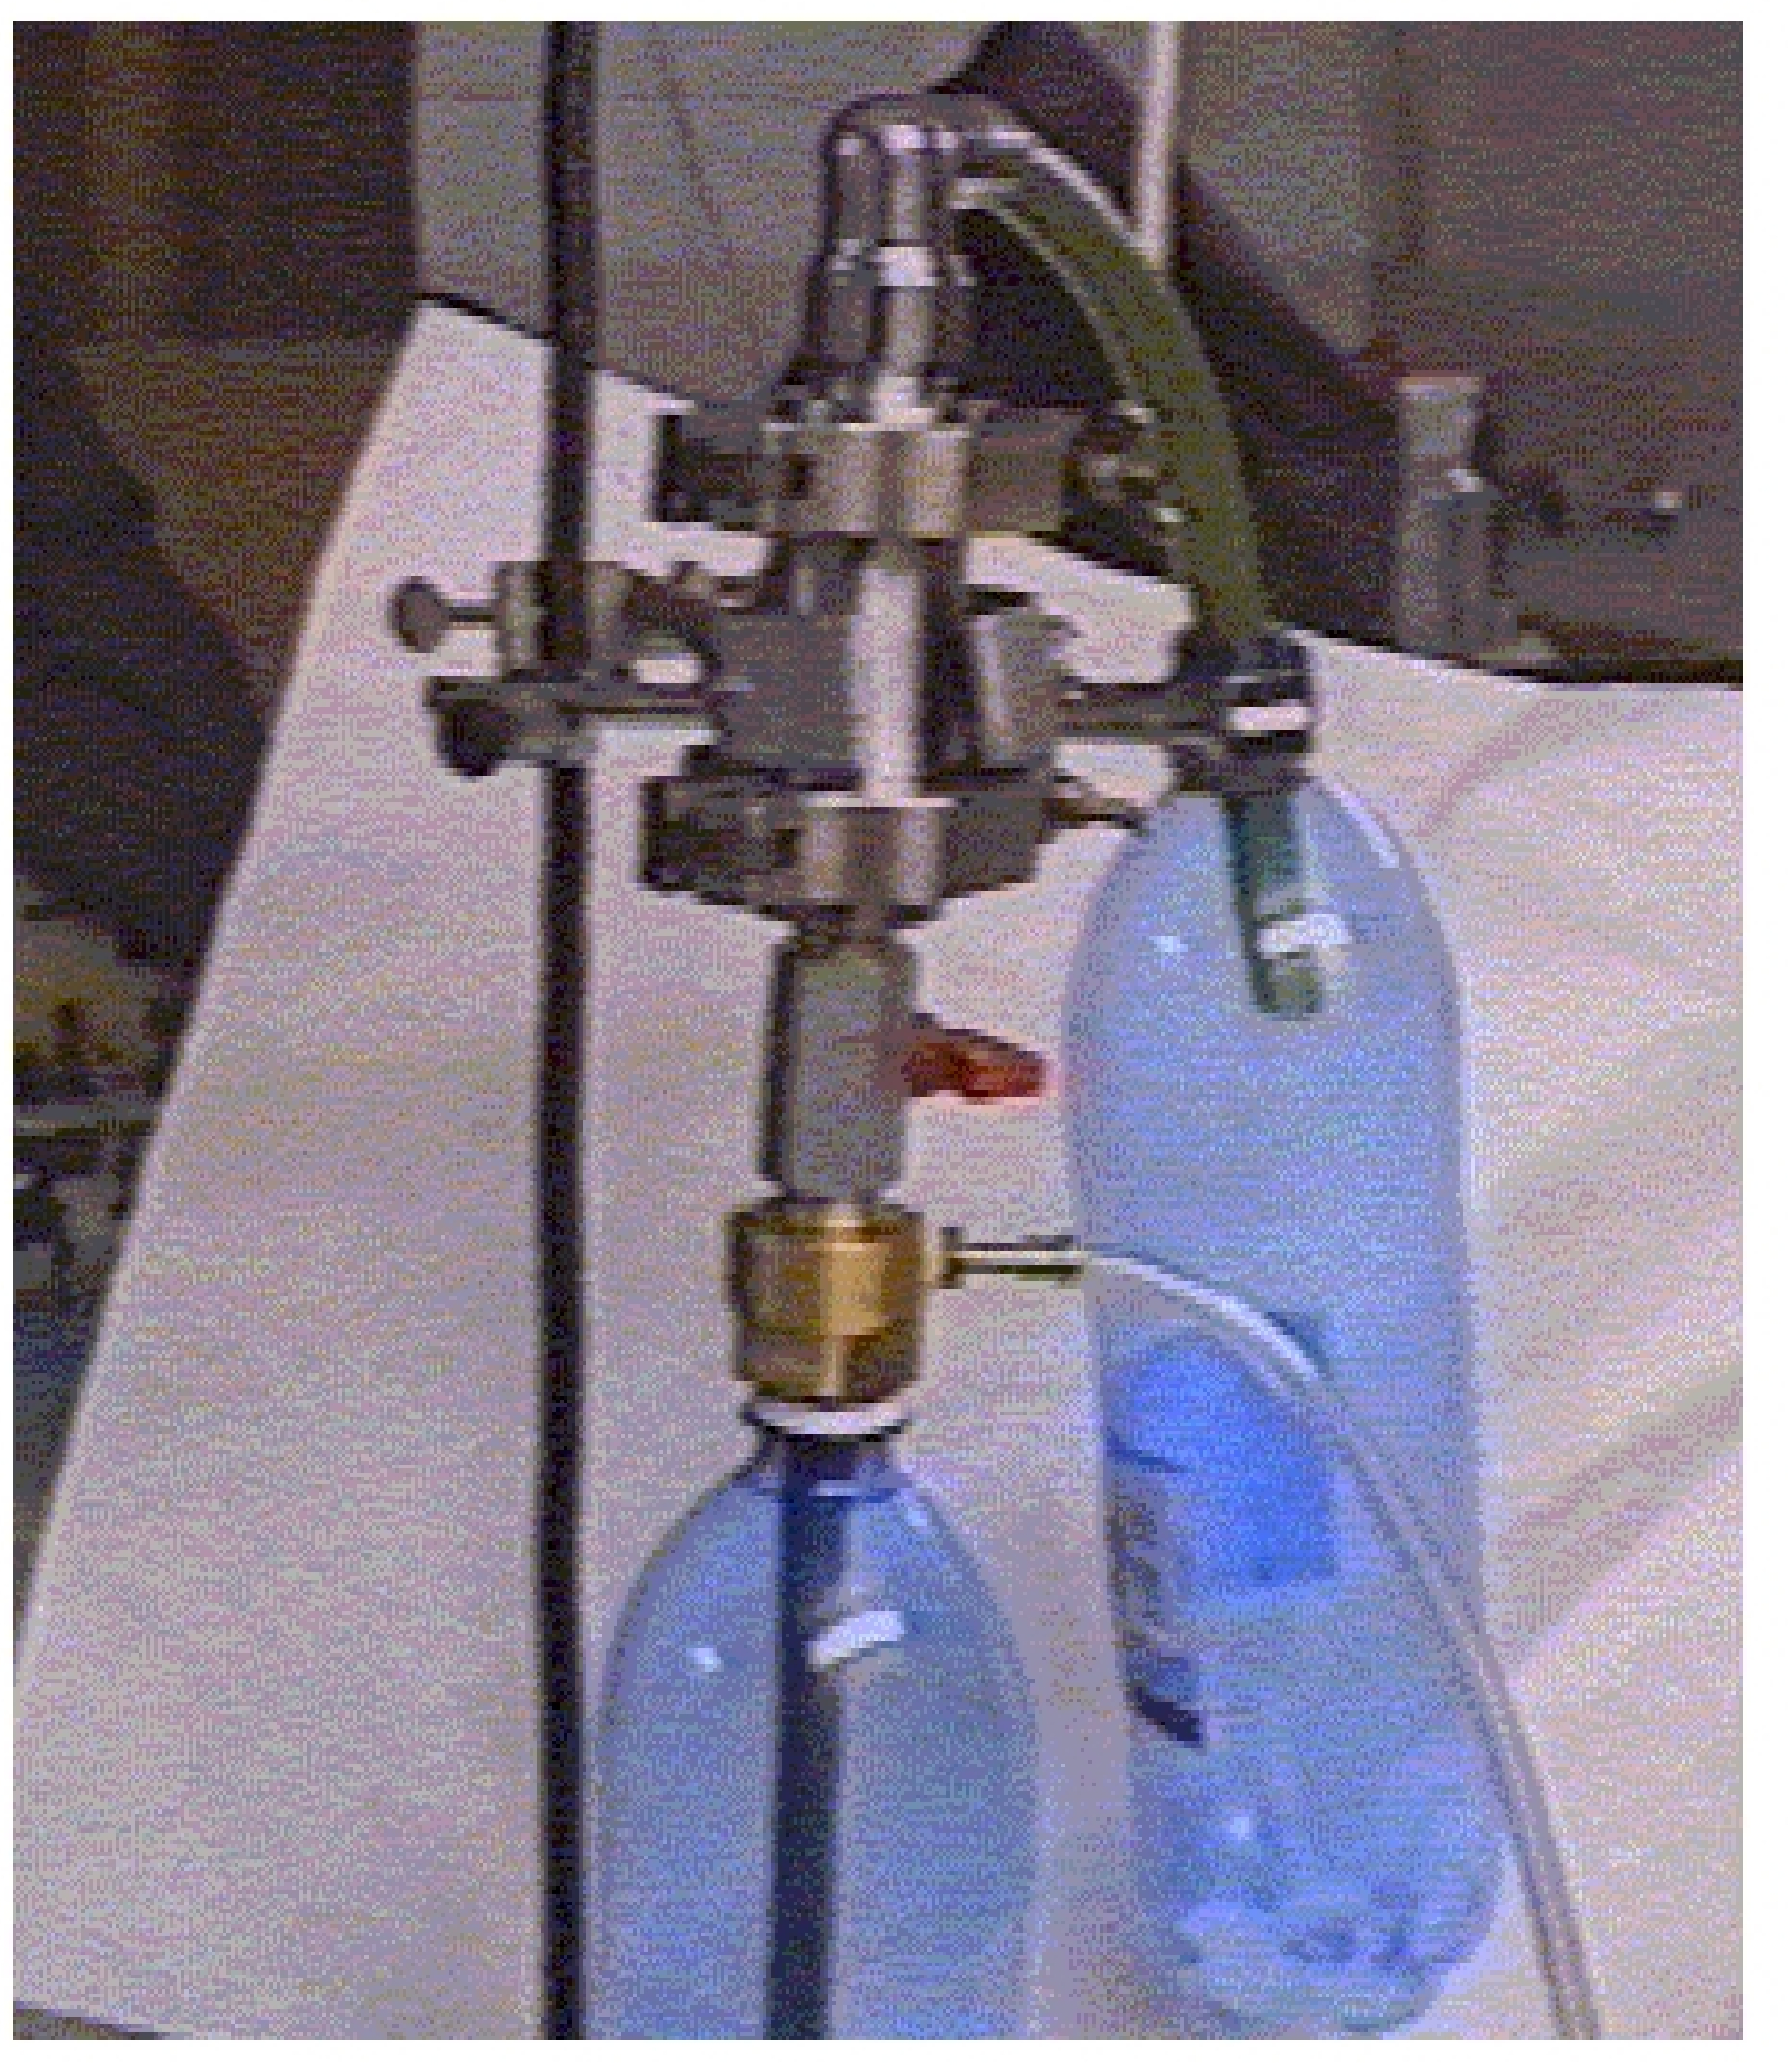

Institut für Strömungslehre und Wärmeübertragung
Technische Universität Graz

Mag. Dr. techn. Renate Teppner
Ass.-Prof. Dipl.-Ing. Dr. techn. Helfried Steiner
O. Univ.-Prof. Dr.-Ing. habil. Günter Brenn

Graz, October 2004

Contents

1 Computed flow configuration - geometry 3
2 Parameters for the numerical simulation 4
2.1 Boundary conditions 4
2.2 Numerical scheme 5
3 Results of the simulation 6
4 Estimation of the maximum dropsize based on the numerical results 17
4.1 Comparison with experimental data 19
5 Discussion and further work 21
6 Emulsification by liquid jet break-up in another viscous fluid ......................................................22

Formal aspects of the project

After finalisation of all formal procedures for establishing the project “EMMA” – Emulsions with Nanoparticles for new Materials, the project started on October 20, 2003. The project is run by three partners – the Institute of Fluid Mechanics and Heat Transfer (ISW) of Graz University of Technology, Graz (Austria), the Laboratory of Chemical Physics and Engineering (LCPE) of the University of Sofia (Bulgaria), and the Department of Mechanics and Physics of Fluids (DMPF) of the Polish Academy of Sciences, Warsaw (Poland).

The kick-off meeting took place at the LCPE in Sofia between Friday, October 31 and Sunday, November 2, 2003. In this meeting, all partners presented their institutions and fields of work. Specific presentations related to the EMMA project were also given by all three partners, where the group from LCPE presented very interesting results of preliminary investigations in the field of emulsification in the presence of surfactants at various concentrations. The essential question there is the population of drops of the disperse phase and its change due to the emulsification process.

The partners agreed upon having a second meeting for mid-term reporting in October 2004 in Warsaw (Poland). In between the PhD student Slavka Cholakova from LCPE made a visit to the DMPF in Warsaw for experiments in the field of emulsification in a narrow-gap emulsifier, and a visit of Prof. K. Danov from LCPE to ISW in Graz is planned for the week between December 4 and 10, 2004.

1 Computed flow configuration - geometry

According to the geometry data provided by Mrs. Slavka Cholakova the key part of the emulsifier was constructed as shown in Figure 1. The total axial extension of the computational domain is L=0.5 m. The diameter at the inlet is D=0.013 m.
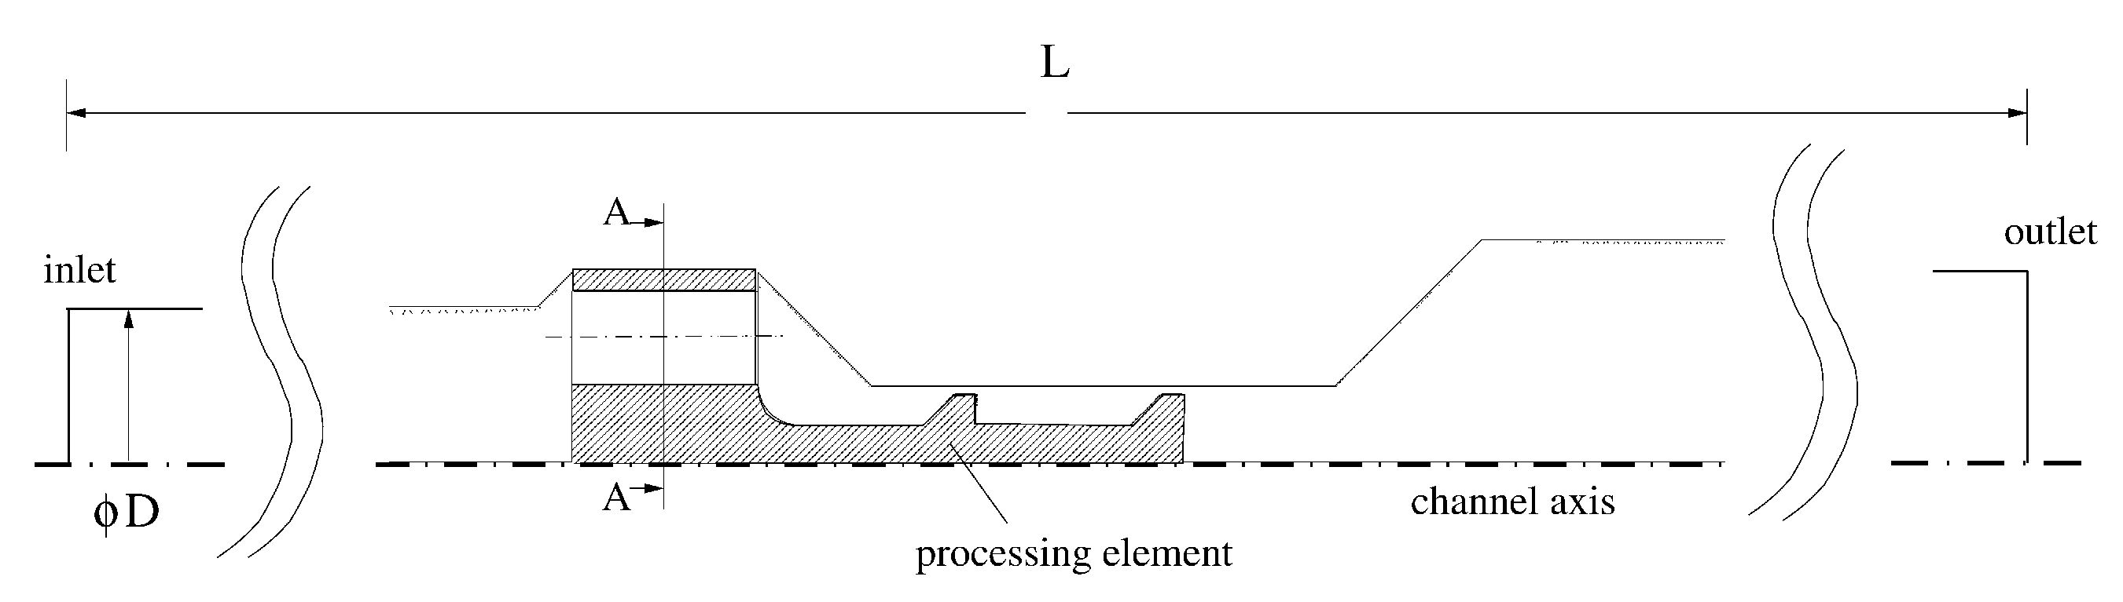
Figure 1: Configuration of the emulsifier.

As it is shown by the cross-sectional view in Figure 2, the processing element's base plate containing six inlet holes exhibits 12 axes of symmetry with respect to the circumferential direction θ. Therefore, the present three-dimensional simulation considered a flow geometry bounded by two neighbouring axes of symmetry. As marked by the shaded slice in Figure 2, the computed flow domain has a circumferential extension of Δθ =30°.

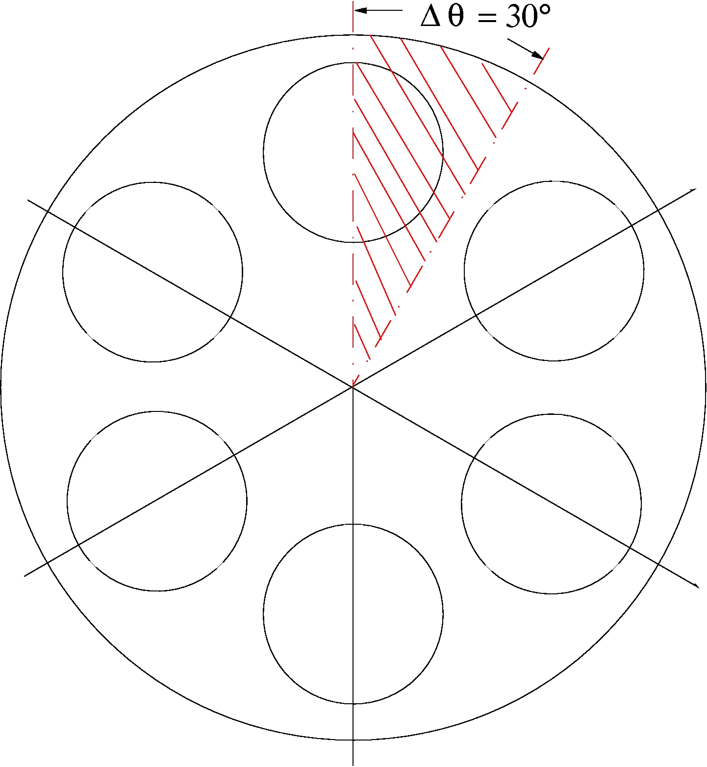

Figure 2: Cross section A-A of the base plate as denoted in Figure 1. The extension of the computational domain in the circumferential direction is Δθ =30°.

Figures 3 and 4 display different views of the flow geometry next to the processing element. The gap width is 395 μm.

