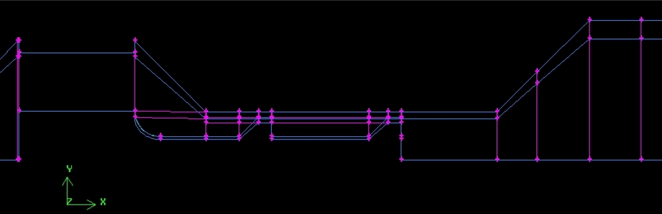

Figure 3: Processing element, gap width 395 μm.

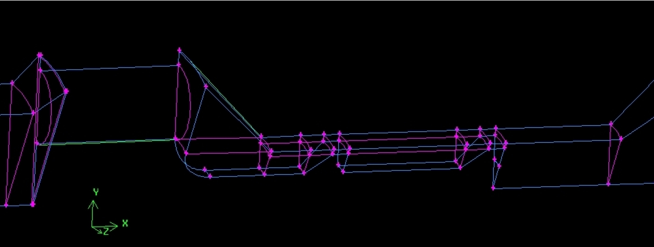

Figure 4: Processing element, gap width 395 μm.

2 Parameters for the numerical simulation

The three-dimensional numerical calculations were done with Fluent 6.1.22. For comparison three different k-ε models (Standard, RNG, Realizable) with enhanced wall treatment were used as turbulence models. Applying the alternative turbulence models did not produce significantly different solutions, as it will be shown in the numerical results.

For the material properties of the working fluid we used the corresponding data of the emulsion, which read ρ= 977.6 kg/m³ and μ= 2.5⋅10⁻³ Pa s, respectively. The volumetric flow rate through the emulsifier was set to $\overset{˙}{V}$= 0.13⋅10⁻³m³/s.

2.1 Boundary conditions

The boundary conditions which were imposed at the different boundary zones shown in Figure 5 are summarized in Table 1.

velocity-inlet | inlet velocity: top-hat profile with the axial velocity v_{x} =0.979 m/s and  turbulence intensity 10%,  the corresponding Reynolds number  based on the diameter at the inlet D=0.013 m is  Re = v_{x} D ρ/μ=4979
pressure-outlet | von Neumann condition for velocity
channel wall  surface of processing element | no slip condition  no slip condition
planar side boundaries | symmetry  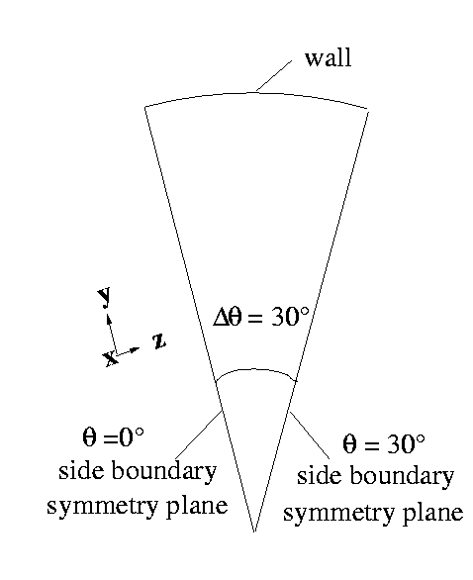
Table 1: Boundary conditions.

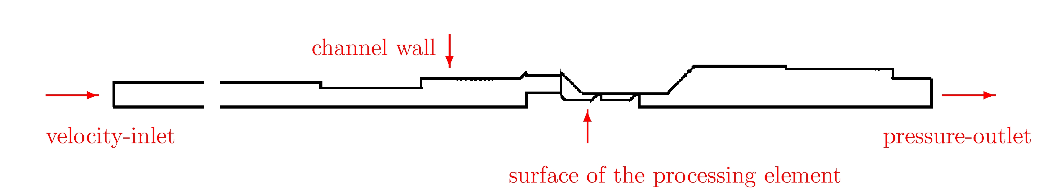

Figure 5: Boundary conditions. At the side boundaries of the domain, i.e., at θ =0° and θ = 30°, respectively, the symmetry condition with respect to the circumferential direction θ was imposed.

2.2 Numerical scheme

The governing set of equations was numerically solved using the following solvers for the pressure field and discretization schemes:

Pressure | Standard
Pressure-Velocity Coupling | SIMPLE
Momentum | First Order Upwind (Standard, RNG),  Second Order Upwind (Realizable)
Turbulent Kinetic Energy | First Order Upwind (Standard, RNG),  Second Order Upwind (Realizable)
Turbulent Dissipation Rate | First Order Upwind (Standard, RNG),  Second Order Upwind (Realizable)

Table 2: Pressure solvers and discretization schemes

3 Results of the simulation

The presented results in the area of the processing element are organized as follows:

Fig. 6 | Velocity-vector plot demonstrating the local direction of the flow particularly in the region close to the processing element.
Figs. 7 - 8 | Contour plots of the axial velocity and the static pressure at different cross-sectional (y-z)-planes downstream from the device. These contour plots are shown to illustrate that the flow after passing through the inlet holes of the processing element's base plate becomes again homogeneous in the circumferential direction very rapidly. This is due to the strong contraction of the flow as it approaches the first narrow gap. Therefore, the flow downstream from the first gap of the processing element can be practically regarded as cylindrically symmetric.

Figs. 9 -11 | Contour plots of the axial velocity component (streamwise direction), of the turbulent kinetic energy, and of the turbulent dissipation rate, respectively.

It is noted that all vector and contour plots shown are taken from the solution obtained with the standard k-ε turbulence model. They are primarily intended to give a qualitative insight into the flow in the region around the processing element.

Figs. 12 - 13 | Sketch of the downstream positions for the analysis of the different flow profiles.
Fig. 14 | Velocity profile in the first gap, at the downstream position x=0.413m
Fig. 15 | k profile in the first gap, at the downstream position x=0.413m
Fig. 16 | ε profile in the first gap, at the downstream position x=0.413m
Fig. 17 | k profile, at the downstream position x=0.4136m
Fig. 18 | ε profile, at the downstream position x=0.4136m
Fig. 19 | k profile, at the downstream position x=0.415m
Fig. 20 | ε profile, at the downstream position x=0.415m
Fig. 21 | k profile in the second gap, at the downstream position x=0.423m
Fig. 22 | ε profile in the second gap, at the downstream position x=0.423m
Fig. 23 | k profile, at the downstream position x=0.426m
Fig. 24 | ε profile, at the downstream position x=0.426m

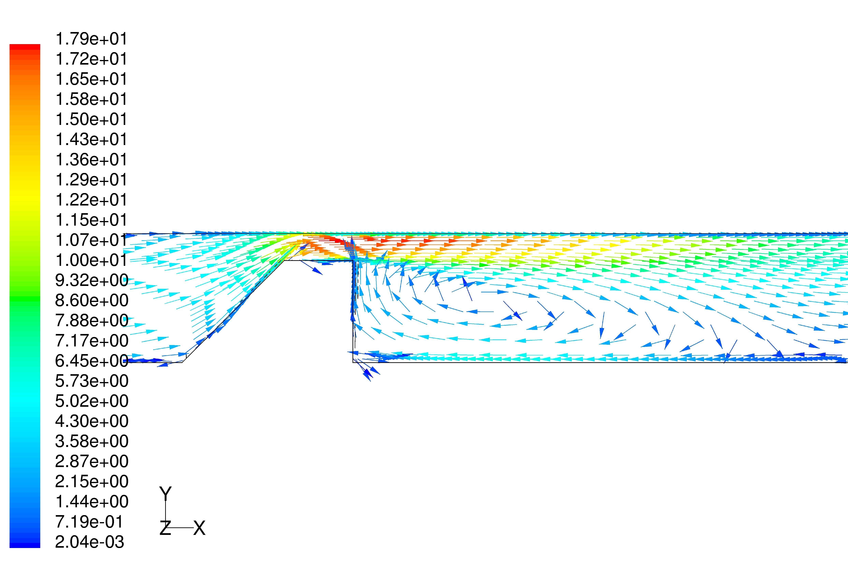
Figure 6: Velocity vectors colored by velocity magnitude (m/s), at the first gap.

As it is indicated by the strong recirculation zone in the wake of the gap, the backflow is significant in this region.

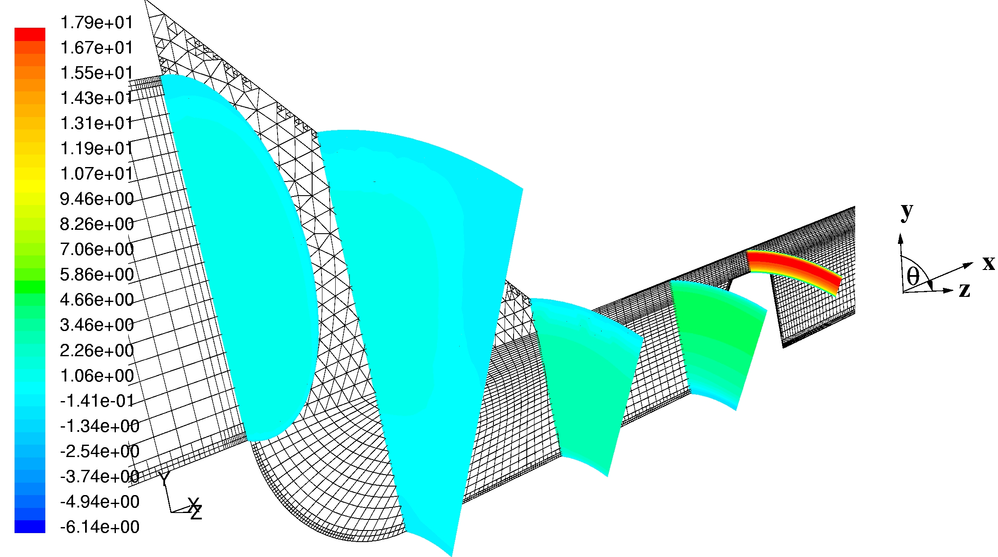

Figure 7: Contours of x velocity (m/s). Flow situation between the base plate of the processing element and the first gap.

It becomes evident that, right after the base plate of the processing element, the flow varies in the circumferential direction θ, which is clearly to be expected. However, approaching the first narrow gap, the flow recovers quickly its circumferential homogeneity. Hence, the flow downstream from the first gap can be regarded as cylindrically symmetric.
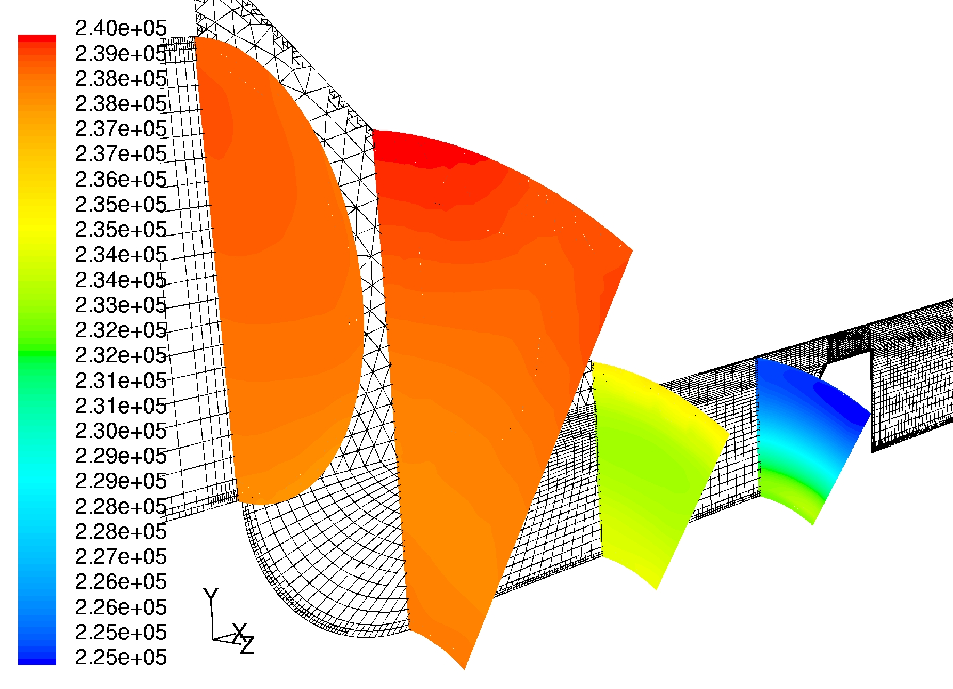

Figure 8: Contours of static pressure (Pa) at different locations downstream the base plate.

As already illustrated by the velocity contours in Figure 7, the recovery of the circumferential homogeneity is also shown by the fact that the isobars become concentric lines the closer they are to the gap.

