Production of emulsions in shear flow, experimental study

S. Błoński, T.A. Kowalewski

IPPT PAN, Swietokrzyska 21
PL 00 049 Warszawa

CONEX mid-Term report 15.10.2004

Introduction

The deformation and disintegration of oil droplets in water are investigated experimentally and numerically to estimate well controlled conditions form production of emulsions. The phenomena of disintegration of droplets depends on the boundary conditions of the interface between carrier fluid and the droplet fluid. The types of conditions when the liquid droplet deform and disintegrate are classified according to experimental observations to several modes: vibrational, stripping and catastrophic. The last one describes turbulent flow disintegration.
Once size of the droplets becomes small enough, the two-liquid system converts to the quasi stable mixture called emulsion. Two main factors are responsible for the mechanical droplet break-up: the flow shear stress at the interface trying to deform it and the interfacial tension opposing droplet deformation. Reducing surface tension by surfactants is one of the most common methods allowing to obtain micro-emulsions at reasonable energy supply. For oil-water mixtures the surface tension due to the presence of surfactant is typically 10⁻² to 10⁻⁴ times lower than surface tension of pure oil-water interface.
From the view point of theory, emulsion represents complex multi-component system where interaction with surfactant molecules depend on orientation. Hence prediction of the actual surface forces acting at the interface depends on instantaneous concentration of surfactant and orientation of its molecules, both changing in time as the interface is formed (Stone 1990). It leads to variable in time surface tension, called dynamic surface tension, responsible for changes of interface properties in a difficult to measure time scales. After droplet break-up, when fresh interface is created, the effective surface tension may very orders of magnitude, before surfactant molecules adsorb at the interface and find their preferred orientation. A typical relaxation time varies from micro seconds to several minutes.

Break-up of droplets
One of the simplest configurations to describe and observe droplet break-up is analysis of single droplet in a shear flow. This topic stems from classical experiments of G.I Taylor (1934) that were motivated by an interest in emulsion formation. According to simple derivations, it was shown that in case of small viscosity ratio between droplet and carrier, the droplet interface deformation in the shear flow can be described as a relatively regular transformation of a sphere to an ellipsoidal form. Under critical deformation ratio the droplet breaks into two satellite droplets. The condition for such break-up depends on the surface tension, shear rate and viscosity of fluids only. A simple relation below allows for evaluation of the equilibrium droplets radius a at such flow conditions:

$a=\frac{2σ\left(μ_{d}+μ\right)}{Gμ\left(\frac{\text{19}}{4}μ_{d}+4μ\right)}$ (1)

where: μ - medium viscosity, μ_{d} – drops viscosity, σ - interfacial tension, G – velocity gradient.

The ratio μGa/σ is usually called Capillary number and for viscosity ratio μ_{d}/μ close to one gives simple estimation of the droplet break-up conditions.

Experimental verification of the Taylor formula gives reasonable agreement only for systems of viscosity ratio close to one. For large viscosity ratio droplets are strongly elongated in a shear flow and form long threads before small droplets separate from the end of the thread tip. This process has been intensively studied numerically by H. Stone and co-workers (1994). Despite spectacular agreement between simulation and experimental results, direct application of their model to emulsions is impractical. It appears that lack of good theoretical models describing hydrodynamics of the droplet break-up under complicated physicochemical conditions at the interface leads to inevitable need for experimental data. In the following we describe our preliminary study of the emulsion produced in a simple, flow driven emulsifier.

Experimental setup for emulsion production

In the framework of the project a simple shear flow induced emulsifier, developed at University of Sophia is used. It consists of a small channel formed between two glass plates and separated by a triangular obstacle (Fig. 1)

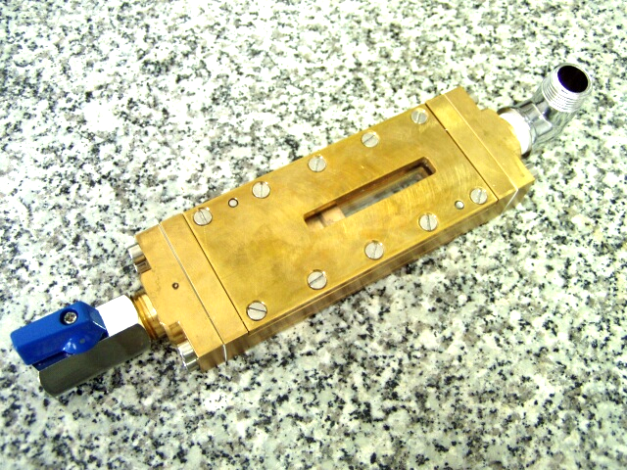 | 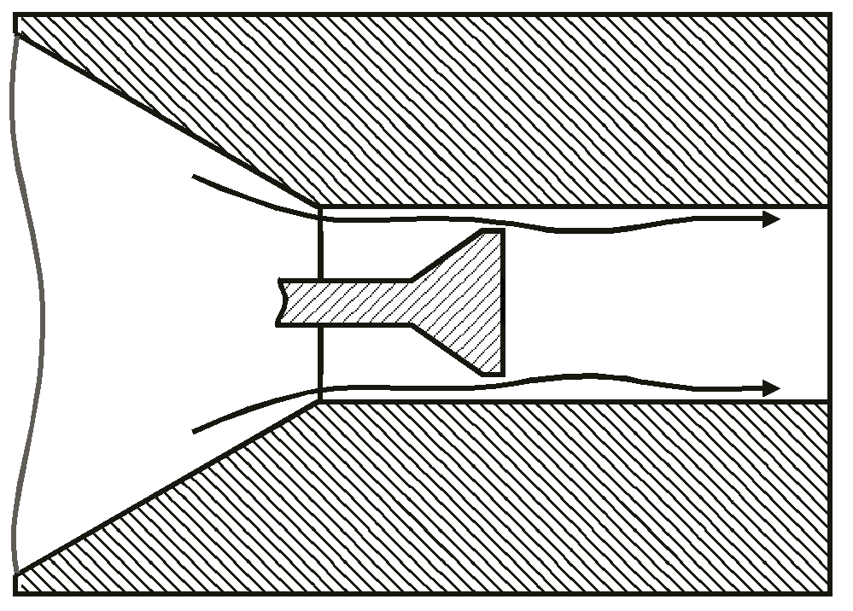
(a) | (b)
Figure 1. Experimental cell of the emulsifier: photography (a) and draft of the processing element inside the cell (b).

Dispersion of silicon oil in water was pumped under pressure through a small slit between the obstacle and side walls of the channel. Observations of the flow have been performed through a transparent top and bottom walls. Dimensions of the channel are 7.5mm x 15mm x 0.5mm and the gap between end of the triangular head of the obstacle and the side walls is 0.5mm. A typical flow rate of the mixture in this study was 60.10⁻⁶ m³/s.

Due to very small dimensions of the channel and microscopic scale of the flowing media standard observation techniques used in the fluid mechanics fail. Hence, for evaluation of droplets size and their velocity a micro-resolution particle image velocimetry (micro-PIV) system has been developed. It permits measurements of instantaneous flow fields in micron–scale fluidic devices for particle dimensions smaller then light wavelength (500nm). It is made possible by using for particles observation laser induced fluorescence, instead of direct particle scattering. Particle Image Velocimetry (PIV) based on correlation of pairs of images is used to evaluate instantaneous velocity field in the channel. These full field data allow for evaluation of local velocity gradients, hence for estimation of conditions for the droplet break-up. The full field velocity measurements will be also used to validate numerical simulations performed for the experimental geometry and flow conditions. Such simulations allow, after their validation, a parametric study of the process and optimisation of the emulsifier geometry.

The acquisition system utilizes an epifluorescent microscope (Nikon ECLIPSE E-50i), double pulse Nd-Yag laser (30 mJ per pulse) and high resolution PIV camera (1280x1024) (Figure 2). Additionally, for the breakup process visualization, a high speed CMOS camera (636 frames per second in full resolution 1280x1024 pixels) was used with a continuous 5W argon laser.

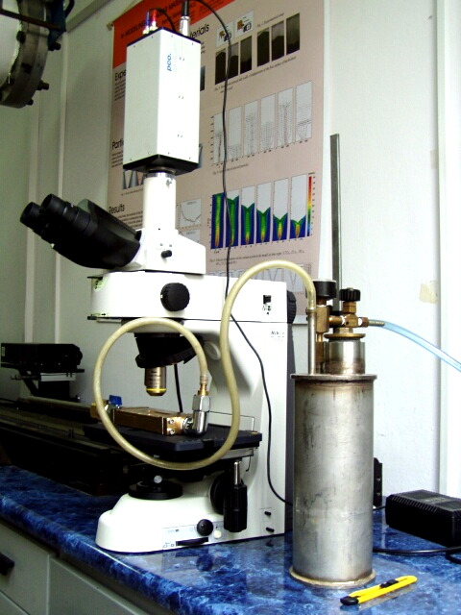 | 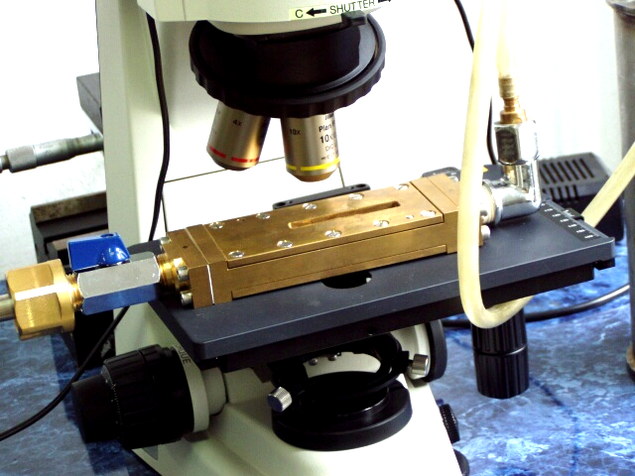
Figure 2. Experimental setup for the micro PIV technique. Container with the oil-water mixture pumped under pressure through the channel, microscope with a high resolution PIV camera.

The flow vector fields are analysed using a double-frame cross correlation PIV algorithm or Optical Flow PIV algorithm. In this technique, the spatial resolution and the accuracy of the velocity measurements is limited by the diffraction limit of the recording optics, noise in the particle image field and the interaction of the fluid with the finite-sized seed particles.

Figure 3a shows an example of the images of investigated micro flow observed under microscope and figure 3b shows velocity field obtained by processing experimental data. Width of images is about 4 mm.

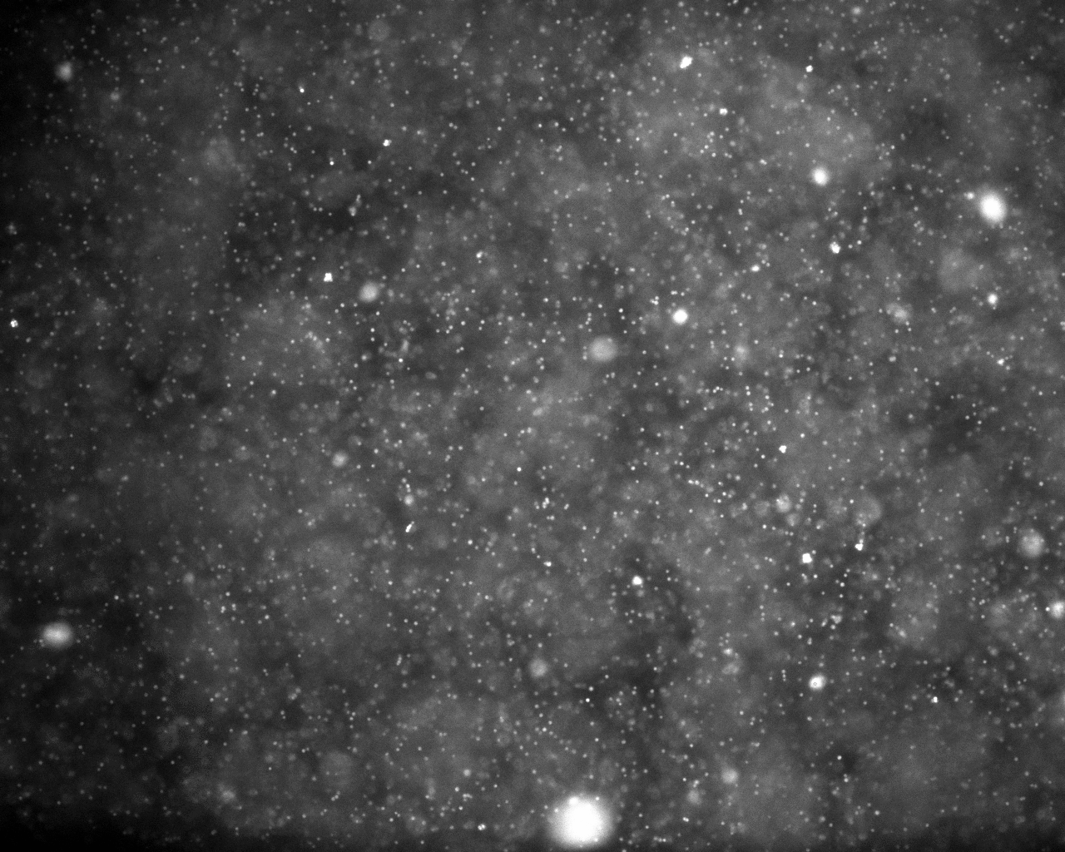 | 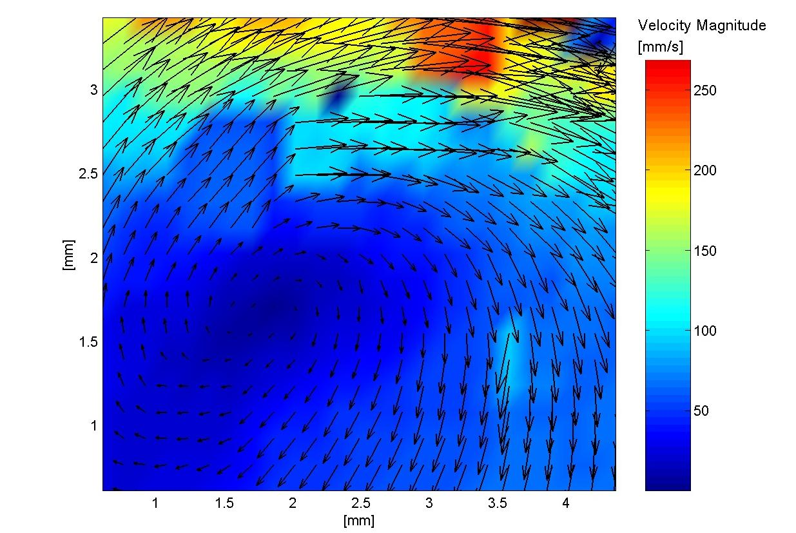
(a) | (b)
Figure 3. Image of the micro flow (a) and velocity field obtained by processing the experimental data.

Numerical simulation
To obtain additional information about the flow structure a three-dimensional numerical simulation for the investigated experimentally flow and geometry parameters were performed. Figure 4a shows configuration of the cell geometry with marked inlets and outlet, which was used for numerical simulation. Figure 4b shows generated mesh in central plane of the experimental cell (only part around processing element). The commercial code Fluent 6.1.22 was used to generate velocity fields and to visualize the flow paths. Table 1 collects conditions of the numerical simulation, which corresponds with the experiment condition. Figure 5 shows an example of the numerical result obtained for simulated flow.

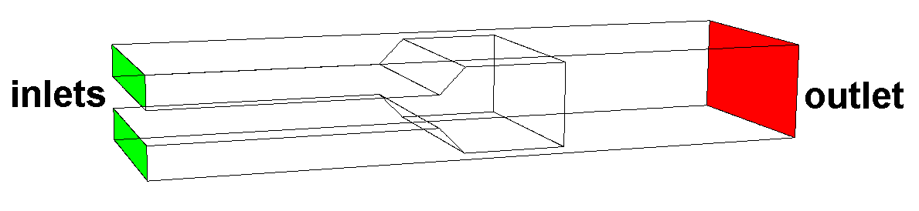 | 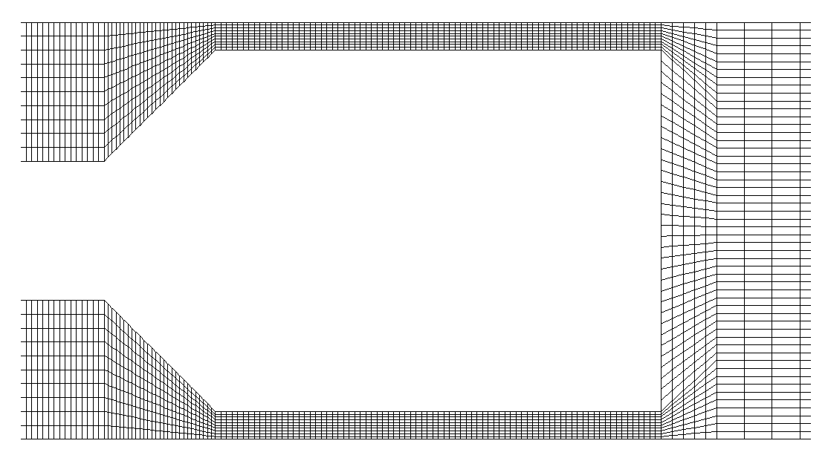
(a) | (b)
Figure 4. Schematic model of the experimental cell (a) and part around processing element of generated mesh (b).

Table 1. Conditions of numerical simulation
Type of flow | 3D, incompressible, steady
Model of turbulence | k-ε
Flowed medium | water
Mesh | structural, 1302111 cells, 4025630 faces, 1422300 nodes
Inlets | velocity-inlet  velocity : 0.8 m/s  turbulence intensity: 8.63%  turbulence length scale: 0.000175m
Outlet | pressure outlet

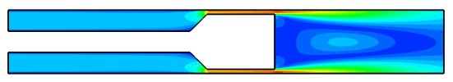 |  | 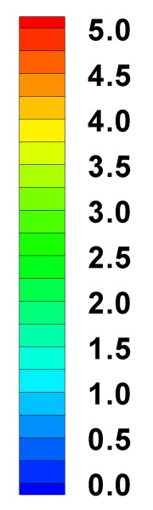  [m/s]
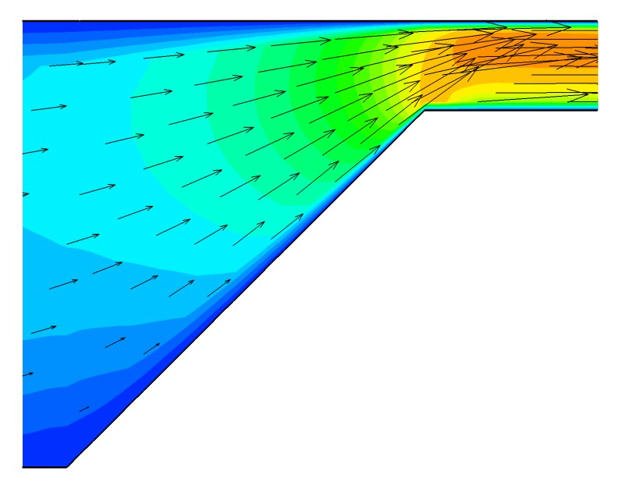 | 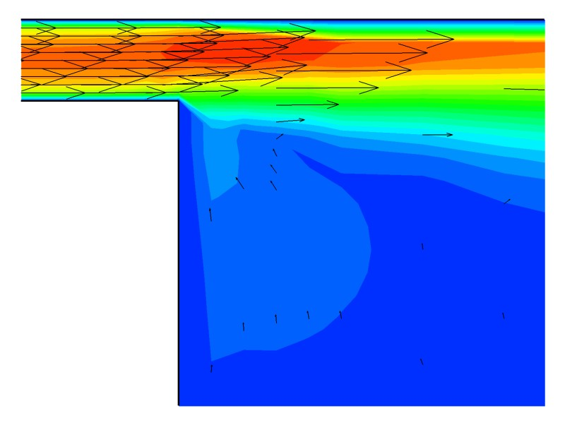
Figure 5. Contours of velocity magnitude and velocity vectors obtained from numerical simulation.

Estimation of droplet radius
Numerical simulation allows for estimation of maximum velocity gradients present in the emulsifier. This gradients were used to evaluate critical radius of the droplets. In the first approach a simple Taylor formula (1) was applied.

Assuming the following parameters for our experimental conditions:
σ = 10⁻³N /m interfacial tension for water-oil-surfactant mixture (we assume about 100 times
lowering of the surface tension)
μ = 10⁻³ Ns/m²
μ_{d} = 0.48 Ns/m²

and taking from the numerical model velocity gradient in the gap
G = 8.85 10⁴s⁻¹
we arrive to droplet radius a = 4.510⁻⁶m.

Large droplets observed under microscope (Fig. 6) seem to be at least one order of magnitude bigger. However, one may find that smallest visible droplets are very close to the estimated value.

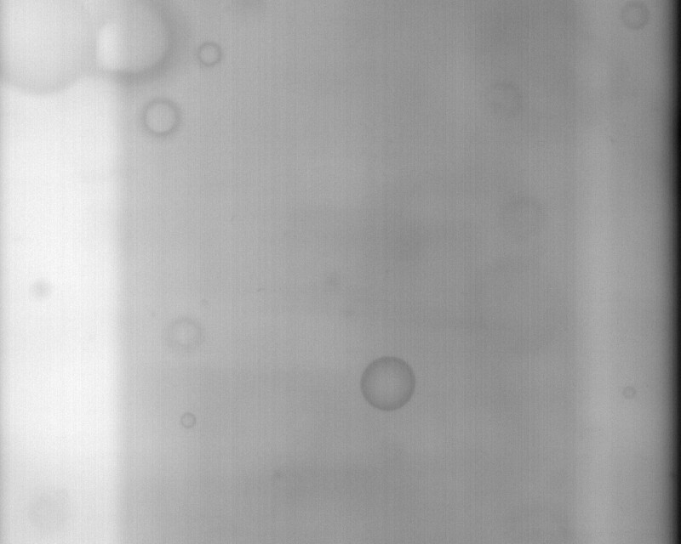

Figure 6. Drops observed under microscope just after processing element; width of image is 2.15mm. Average size of droplets 0.17mm, smallest visible droplets 10⁻⁵m

Conclusion
Our preliminary study has shown applicability of the apparatus for analysis of the flow of emulsion in the microscopic channels. Further work is in progress to improve velocity field evaluations method. At the moment the main problem met during present experiments was damage of the microscope lenses by high energy light pulses of Nd-Yag laser used for the flow field illumination. Short, high energy light pulses are necessary “to freeze” motion of particles observed at high magnification of the microscope. Sharp images of fast moving fluorescent tracers are necessary for the PIV velocity evaluation. It appeared that additional effort has to be done to protect the optical system.

References:
- Taylor G.I (1934) The formation of emulsions in definable fields of flow. Proc. R. Soc. London A146, 501-523
- Stone H.A., Leal L.G. (1990) The effect of surfactants on drop deformation and breakup, J. Fluid Mech. 220, 161-186
- Stone H.A. (1994), Dynamics of drop deformation and breakup in viscous fluids, Annu. Rev. Fluid Mech., 26, 65-120.

